Construct a regular pentagon worksheet
Yue Kwok Choy
There are many different ways to construct a regular pentagon using a pair of compasses and a ruler. Below are some diagrams of various constructions. It is somewhat like reading a detective story to find out how they work, without the construction instructions given. See whether you can draw them one by one.
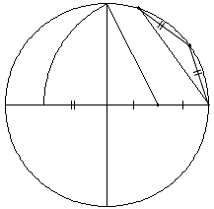
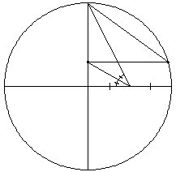

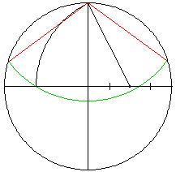
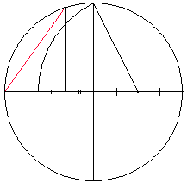

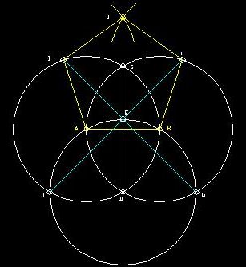
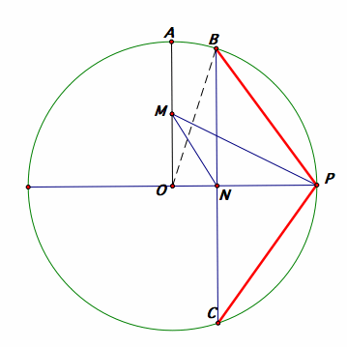
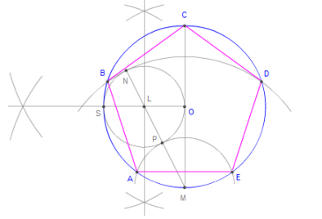

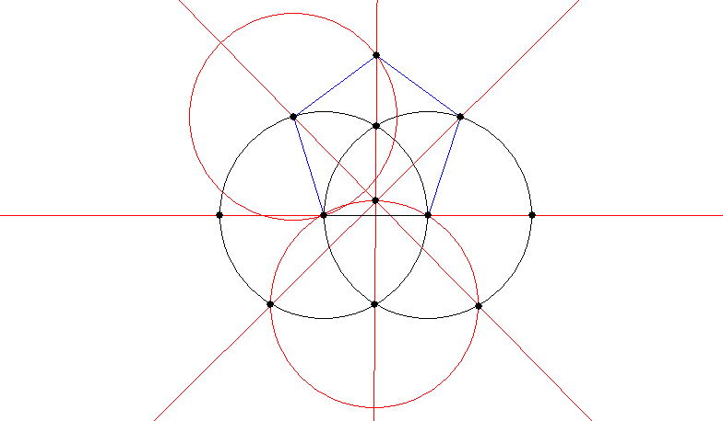

Lastly make a regular pentagon using a strip of paper:
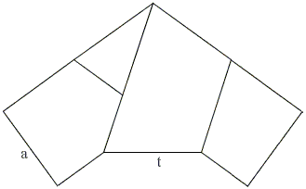

and cutting a pentagon:

